# Reviewer 4

Gunder et al. examined the effects of dexamethasone treatment on parameters of skeletal muscle atrophy in mice fed either a High-fat diet or standard chow. This work builds on their previous work by Harvey et al. (2018), where the authors observed impaired glucose tolerance, decrease fat mass, hepatic steatosis, and increased lipolysis. They demonstrate that HFD-dexamethasone animals weight less than their HFD-vechile controls despite consuming significantly more calories.  The discrepancy in the mouse body wright was due to less fat mass and lean mass. They comprehensively demonstrate that dexamethasone treatment decreases muscle strength, fibre type and cross sectional area. However, despite the reductions in muscle mass and strength, the authors did not observe differences in markers of the E3 ligases, MuRF1 and Atrogin-1.  The manuscript is well written, relevant, but could be improved from the addition of some molecular work.

Main comments

1. Please include main effects of the diet and dexamethasone treatment either in text or present on graph, as it is hard to interpret where there are main effects.

**After consultation with our statistical team, we think it can be misleading to report main effects when there is a significant interaction term. Since our primary outcome is the interaction between glucocorticoids and diet, that is what we reported. All statistical tests are reported in our online data supplement**

1. Change the title as it currently a bit misleading. I think switching “promotes” to “exacerbates” or “augments” is more suitable, as there appears to be some main effects of treatment with the dexamethasone for loss of muscle strength, CSA and mass.

**We have changed the title to augments, and thank the reviewer for this clarification.**

1. Add westerns for MuRF1, Atrogin-1, FOXO3, and LC3BII/I. In its current state, the manuscript is only descriptive and would benefit from the addition of molecular explanations to the changes observed.

**We have added western blots for Akt in Figure 4C-D but were unable to complete blots for the other factors in time for this revision due to limited laboratory access by our researchers. We have noted this as a caveat in the discussion.**

Other:

1. Please include % fat free mass and lean mass at sacrifice on table 1. While this data is available to some degree on figure 2A, it would be more comprehensive and clear to also list the data at time of sacrifice on table 1 for a complete overview of body composition.

**We thank the reviewer for this suggestion. Both percent fat mass and lean mass at sacrifice have been added and referred to in the text.**

Also please include the gastrocnemius weights normalized to body weight, as the reduction in mass could be attributable to the decrease in body weight in the dexamethasone treated mice.

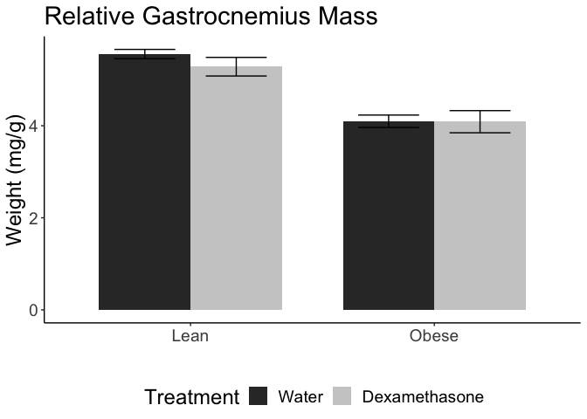

Gastrocnemius weights normalized to body weight at sacrifice. No significant differences in relative gastrocnemius weights once normalized to total body weight.

**This is an excellent clarification and this information has now been included in the text of the results section. Indeed, the reductions in gastric weight are proportional to reductions in both body weight and lean mass, and as such after normalizing for lean mass there are no significant effects of dexamethasone (p=0.386 or interactions of dexamethasone treatment with diet (p=0.486). There is of course a main effect of diet, due to dramatically different body weights (p<0.001). These data are presented here graphically and described in the revised results section:**

**There were no significant changes in relative gastrocnemius weights due to dexamethasone treatment after normalization to total body weight (pinteraction=0.486, pdexamethasone=0.386). We interpret this to indicating that the individual muscle mass changes were proportional to changes in total body weight, and that this was largely driven by reductions in lean mass.**

1. There is a formatting error on table 1 for fluid intake per day.

**This formatting error has been fixed**

1. Were mice activity levels recorded? Could changes in physical activity account for some of the differences observed?

**No physical activity was not assessed. It is plausible that reduced activity could affect glucose uptake or body weight changes. We have noted this as a potential caveat.**

1. Is the fluid intake for HFD-water vs. Chow-water animals significant? Could this potential increase in fluid intake be do to impaired glucose tolerance?

**No the effect on water intake is not statistically significant. We reported in Harvey et al 2018 that longer dexamethasone did result in increased water intake but we posit that this is due to extreme hyperglycemia and excessive urination. As such, in this study we used a shorter time course to limit this potential confounding possibility.**

1. “In NCD animals, the force generated by nerve stimulation was reduced 10% when treated with dexamethasone.” Is this significant? As Figure 1C does not reflect this. Same for the 11% reduction for muscle force figure 1D. If not statistically significant, I think it would help to list the p values of the main effects of diet and dexamethasone for clarification.

**As above, our primary outcome throughout the paper was the interaction between diet and treatment. The asterisks in Figure 1C-D indicate a significant interaction between diet and treatment. As to the question of whether the pairwise effects of dexamethasone are true in each of the subgroups, these do reach statistical significance for both all groups. For clarity we have added this to the revised results section:**

**Dexamethasone had significant effects in both groups for both muscle (p=0.016 for NCD and p=0.005 for HFD via Student’s *t*-tests) and nerve stimulation (p=0.015 for NCD and p=0.003 for HFD).**

1. It would be better to present the muscle CSA data before presenting the muscle force-CSA regression.

**We appreciate this comment, but in order to keep all the muscle structure data together we have elected to keep CSA in Figure 2. To assist with interpretation we have now mentioned differences in CSA earlier in the results section:**

**In order to examine whether changes in muscle strength were proportional to declines in muscle size, we plotted a regression of force versus whole-muscle cross-sectional area (CSA; Figure 1E-F). The quadriceps CSA was significantly lower for the dexamethasone treated groups and this was enhanced by obesity (Figure 2C).**

1. Please mention in text that the stain for fibre type assesses SDH activity.

**We added this clarification to the revised results section:**

**In order to evaluate any changes in the ratio of oxidative versus non-oxidative fiber-types, we stained muscle sections and quantified the muscle fibers based upon their oxidative capacity. We used NADH/NBT staining which is responsive to succinate dehydrogenase activity.**

Is there a main effect of diet/obesity for decreased type IIa/IIb?

**Based on mixed linear models to account for repeated measures within a sample, and removing the interaction term we found that there was a significant main effect of treatment (p=0.001) but not diet (p=0.159) in medium stained fibers. In light stained fibers, we similarly observed main effects of treatment (p=0.004) and diet (p=0.01). We have added this clarification to the revised results section**

**There was a main effect of dexamethasone treatment in all fiber types except oxidative (p=0.001 for light, p=0.004 for medium and p=0.449 for dark stained fibers). There was a significant main effect of diet reducing fiber size in light (p=0.01) but not medium (p=0.125) or dark stained fiber (p=0.425).**

1. Include the 15 day time point of gene data in figure 3 as bar graphs that show the 4 groups. Also the asterisks are missing on the current figure 3 to what is significant. From the text it looks like 7 days of treatment increases FOXO3, MuRF1 and Atrogin, but this is not reflected in the figure.

**The data for the 15 day time point is presented in Figure 3. None of these comparisons reached statistical significance, though several were close. This is why there is an absence of asterisks. This is clarified in the revised results text**

**After one week of dexamethasone treatment, we observed induction of *Foxo3* and the atrogenes, *Trim63* (Atrogin-1) and *Fbxo32* (MuRF1), to be greater in obese mice compared to their lean counterparts, though the interaction between obesity status and dexamethasone treatment did not reach statistical significance for these transcripts (Figure 3).**

1. It would be interesting to include western blots for MuRF1, Atrogin, phosphor and total FOXO3. Along the same lines, it would be good to include a marker of autophagic flux such as LC3II/I, as changes in autophagy could contribute to the reductions in muscle mass.

**We agree these are interesting questions, but unfortunately are unable to complete these experiments in time. We are perusing the role of mTORC1, obesity and GC-dependent changes in autophagy and hope to publish that work once research operations are fully re-established.**

1. In the discussion, it is mentioned that the mechanisms contributing to selective fibre type loss following dexamethasone treatment is unclear. It would be good if the authors expanded on their current data set to include markers involved in pathways known to induce fibre type switching such as ERK1/2, MAPK etc.

**In Figure 2G we present data that total oxidative fiber type proportions are not significantly, though selective fiber type loss does remain a possibility, especially if there is fiber-type specific turnover with both myogenesis and myoatrophy occurring. A separate study is being done to evaluate the single-cell dependent changes underlying this phenotype and we look forward to evaluating those markers in that work. We thank the reviewer for the excellent idea.**

1. The primer sequence for NR3c1 is missing.

**This has been added, we apologize for the oversight.**